- Minocqua Winter Park Foundation Board Meeting Dec. 18,2023
- Minocqua Chamber of Commerce Building
- Meeting was called to order at 6:30 PM by President Jo Horton
- Attendance: Board members Ken Aldridge, Jo Horton, Jon Hollander, Jake Van Hefty, Greg Popovich, Wes Doak, Jim Bruno were present.
- (ED) Adriane Morabito
- Quorum achieved
- Minutes were approved with a correction that Jim Bruno was present at the previous meeting Nov. 13,2023. Motion by Aldrich, seconded by Hollander and motion carried.
- A motion to approve the evening’s meeting agenda was made by Hollander and seconded by Aldrich. The motion to approve the meeting agenda carried.
- President’s Remarks:
- Horton remarked that it is time to reboot the fund raising activity. MWP foundation is now only a 501c3. The organization was previously a 501c4 and 501c3. The Legacy Society may benefit from the RMD of 401k savings of our senior citizens who support MWP. Otherwise taxable distributions from the 401 K would become tax free.
- Funding of an endowment fund was discussed. This fund will be established. Typically, a certain asset goal must be achieved before distributions to MWP can be made, so that the endowment fund survives into perpetuity.
- Ken Scoville is willing to spearhead the fund raising. Horton will contact him to discuss the particulars.

Treasures report:
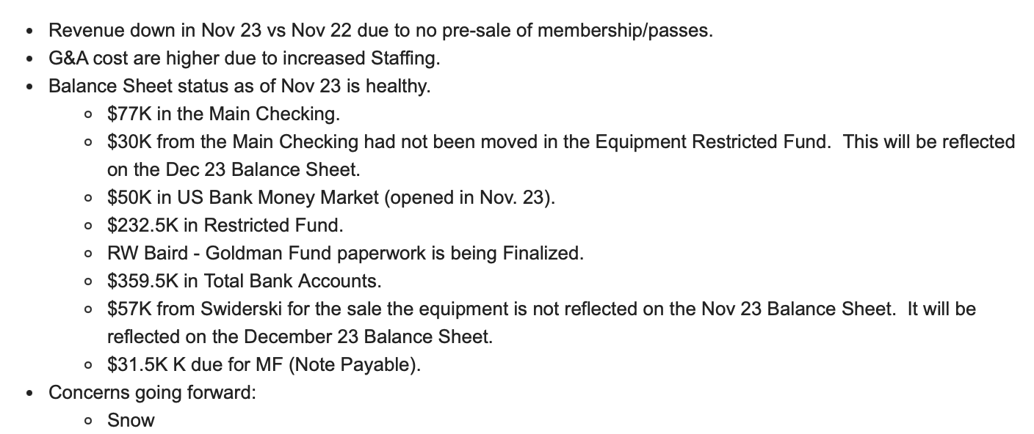
The restricted funds and working checking account will be combined into the working checking account. Restricted funds will be segregated in the accounting reports.

Stephanie will close the books by the 5th of each month. The Treasurer, book keeper and ED will review for accuracy.

A financial policy statement was forwards by the treasurer, Popovich. Please review and send him corrections, additions or thoughts. This will be voted on as a policy at the next foundation meeting.

MWP P&L budgeted v. actual
https://mail.google.com/mail/u/0?ui=2&ik=b8b96db09c&attid=0.1.1&permmsgid=msg-f:1785288579381211440&th=18c69e810b943130&view=att&disp=safe

Profit and loss Oct-Nov
https://mail.google.com/mail/u/0?ui=2&ik=b8b96db09c&attid=0.1.3&permmsgid=msg-f:1785288579381211440&th=18c69e810b943130&view=att&disp=safe

Balance sheet
https://mail.google.com/mail/u/0?ui=2&ik=b8b96db09c&attid=0.1.5&permmsgid=msg-f:1785288579381211440&th=18c69e810b943130&view=att&disp=safe

Capital Cost Nov
https://mail.google.com/mail/u/0?ui=2&ik=b8b96db09c&attid=0.1.7&permmsgid=msg-f:1785288579381211440&th=18c69e810b943130&view=att&disp=safe

Income statement
https://mail.google.com/mail/u/0?ui=2&ik=b8b96db09c&attid=0.1.9&permmsgid=msg-f:1785288579381211440&th=18c69e810b943130&view=att&disp=safe

Executive director report:
Highlights include: All the front desk volunteers have returned.
Tom Camel(sp?) will maintain the skating rink.
Tickets for events can now be bought online in advance of the event or race.
The memorial bench program has sold two benches without any marketing.
MWP has a hospitality specialist who will be on staff the chalet especially during peak utilization days.
Despite the lack of snow, MWP will host events every day during the holiday season.
Volunteers can now sign up for the Wolf Track event.

https://docs.google.com/document/d/1Mvzgoon7UCw0DVv9QBtX9gJtHrVhkKMe/edit

Executive committee:
The strategic plan was discussed. There was general consensus we should examine a new chalet and snow making equipment. A motion was made by Bruno and seconded by Aldrich that board members send suggestions to Horton, of capable members of the community to be included in ad hoc committees, to investigate snow making equipment, costs and staffing, and the investigation of the style and costs of a new Chalet. The motion carried.
At least one board member would have to be on each ad hoc committee. The ad hoc committees need not be exclusively board members. With visual plans in hand, the community support can be gauged, and a time line for implementation recognized. The rate of financial run-up to funding the endeavors will have ramification regarding whether to remodel the existing chalet and/or add an addition to the current chalet. Long term plans would likely positively impact the negotiations for a longer operating agreement with the town of Minocqua.

Also please submit suggestions for new board members to Horton. It was recommended that we solicit board members through our newsletter, including the January newsletter. Desired qualifications to list in the solicitations include accounting, finance, marketing, public relations, fund raising, architectural, and building experience.
Applications for a board position are due Feb 17th 2024, 30 days before the March 18th meeting and election. Applications are available on the MWP website (correct Adriane?). The board may appoint new board members between elections, but that person must then be elected to stay on the board at the next election.

The executive committee has recommended that MWP hire a chalet manager for day to day operations. Adriane will define the roles of the chalet manager, and the role of a development director for board review as an agenda item at the next board meeting.

Land Stewardship report:

See below.

No other committee reports were presented.

A motion was mad by Aldrich to adjourn the meeting, seconded by Hollander. The motion carried.

The next meeting of the Board will occur Jan. 15th, 2024. Location: Minocqua Chamber of Commerce, 6:30 PM. Zoom option will be available.

